Morse Decode from Andrew Sewell
Solution to General Gates’ message:
ALL TROOPS REPORT MOST TOO LOAN FOR A TECHNOLOGY REFRESH
ALL TROOPS REPORT TO BOOT CAMP FOR A TECHNOLOGY REFRESH

What my machine did on the weekend; pseudocode
In essence, how I solved the morse message. I would document this in MS Visio but it is a PITA.

Note:
PartialSolution.remainder is the unsolved portion of morse
PartialSolution.SolutionList is the collection solved words

PartialSolution.Solve()
Foreach word in the military dictionary
{
If word.IsMatch(beginning of partialSolution.remainder)
{
New PartialSolution p = this.Clone;
Add word to solution list of p;
Remove word.morse from beginning of p.remainder;
If p.remainder.length = 0
{
Add p to complete solutions
}
Else if p solution list has too many words or too many Es of Ts
{
Add p to discarded solutions
}
Else
{
p.Solve //recursive call
}
}

}
END

Included files
* VS2005 console project files : I could not use netfx3.0 and VS2008 (‘the new technology’ ?) because I don’t have it.
* text files in /data folder. App.config refers to all files.

Software bug: 9 solutions generated: none correctly validated

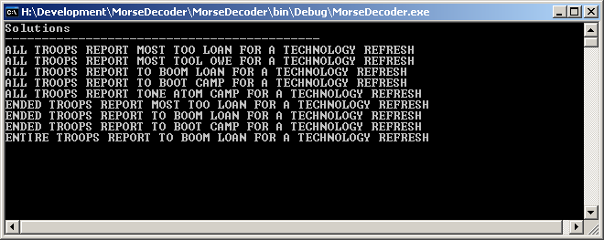

Genuine Solution
I realise now that there is an omission in the software: it does not validate the character counts on the complete solutions. I am not going to run the software again. Calculated the genuine solutions by hand, from the above unvalidated solutions.

Thanks for the fun.
Included files

